**HEB iOS NATIVE APPLICATION**

Splash Page [ first time launching page ]

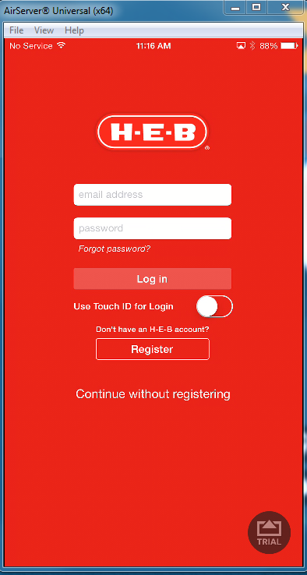

On clicking with Continue without registering

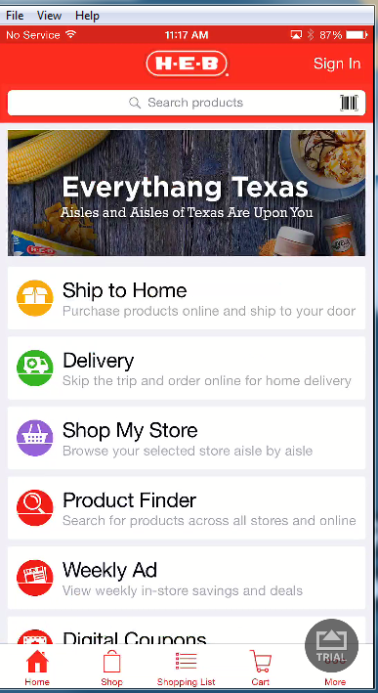

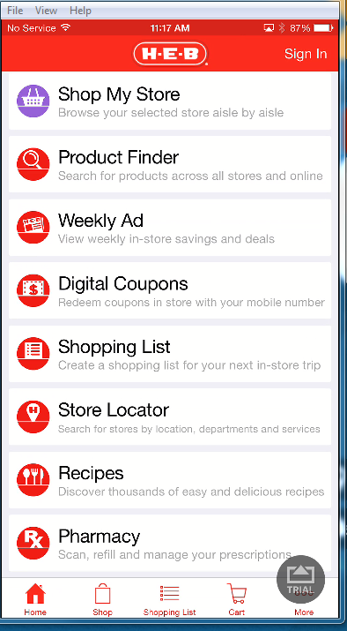

On clicking on Products

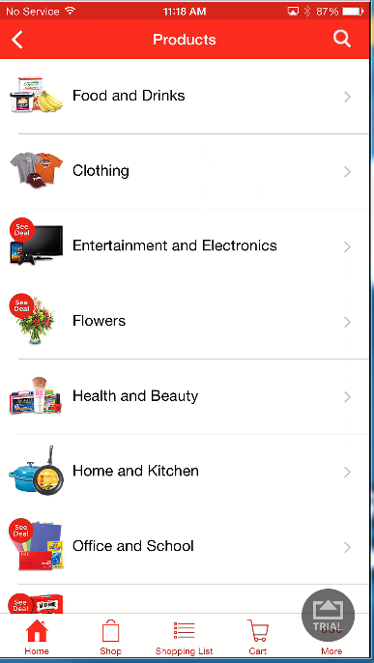

On clicking Food & Drinks , options will get drill down to as below

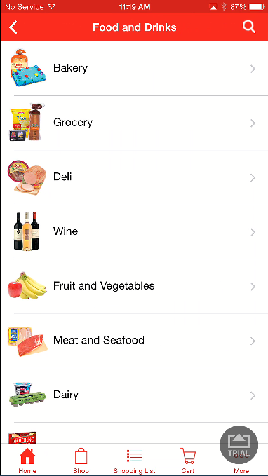

On clicking Bakery

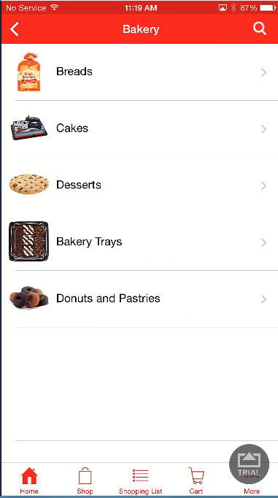

On selecting Breads

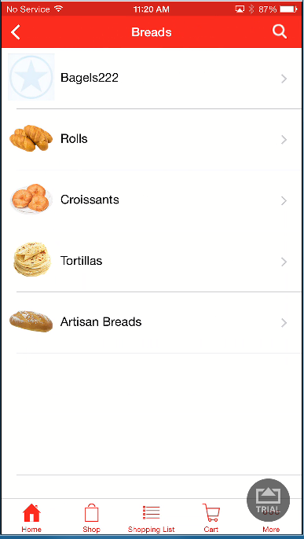

On selecting Rolls

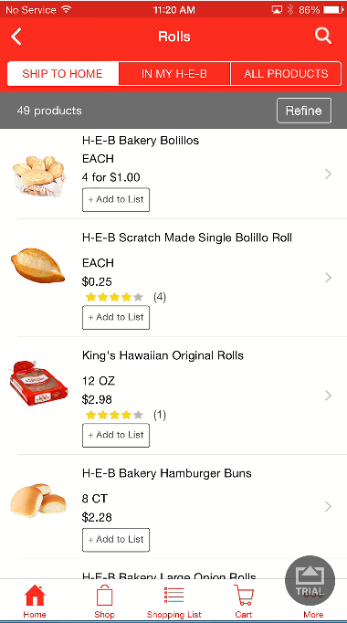

On choosing an specific product

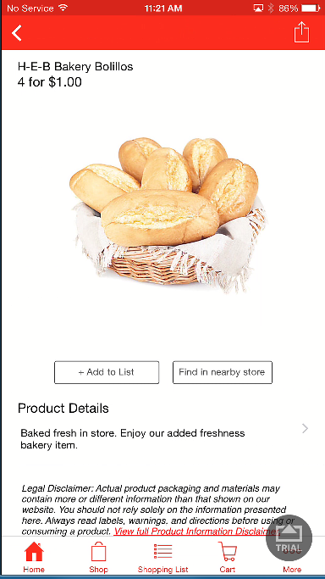

On clicking “ Add to List “

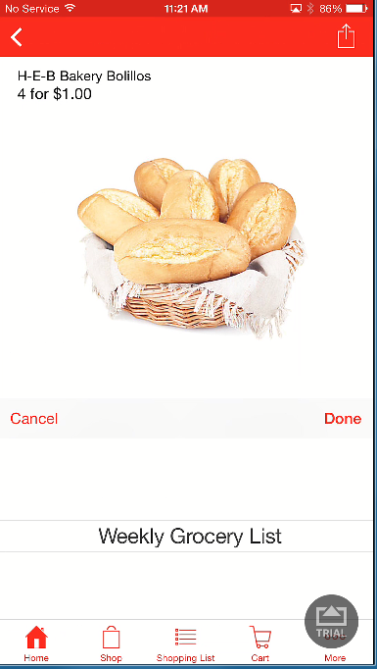

We can see the slider to choose the Shopping list . But for cold user we will have only one list as “Weekly Grocery List”

On clicking “ Done”

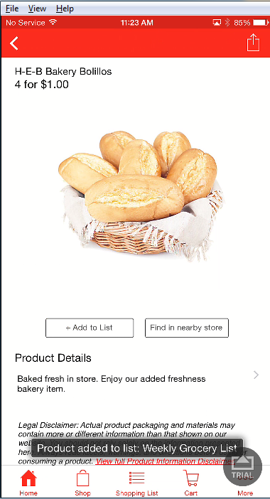

Will get the toaster message as above

On clicking “ Find in nearby Store “ button we will get the option as below to all location access[ if its not already set in the device ]

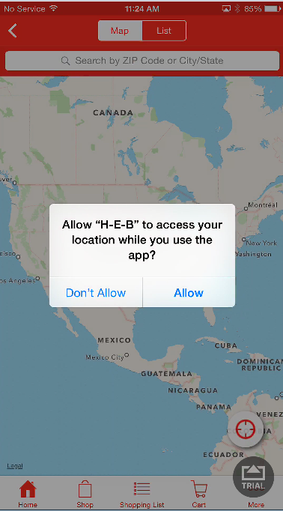

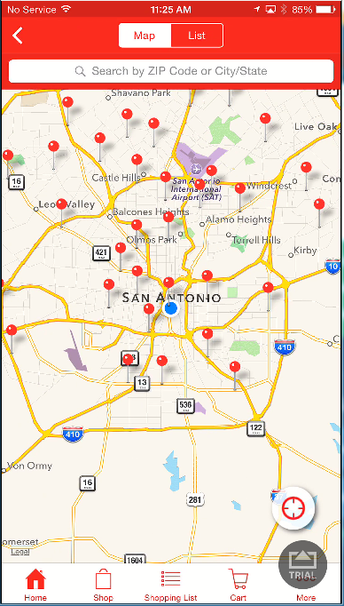

We need to select an store locator from the above Map

I have chosen an Store as below

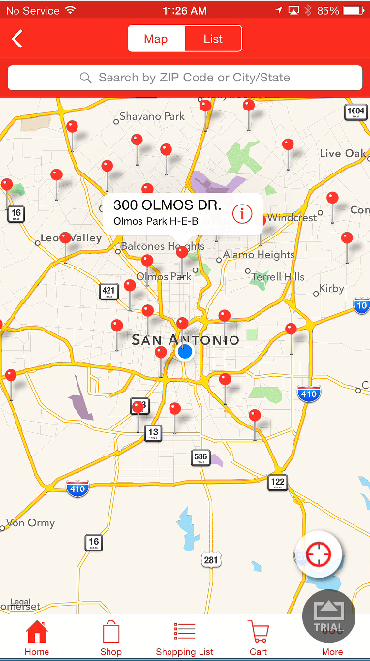

Store Details page will be displayed as below

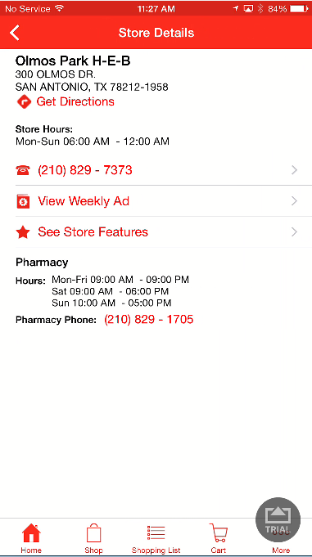

On clicking the Phone number

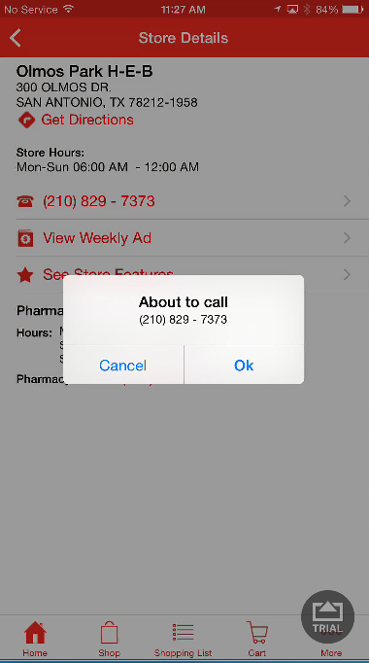

On clicking the weekly Ads

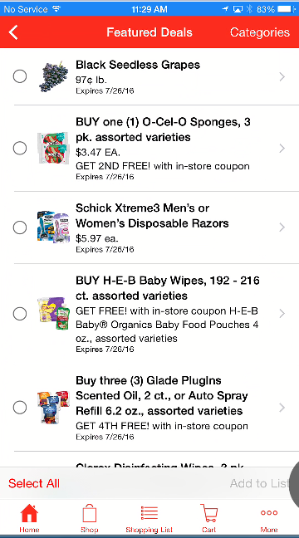

On clicking the “<” icon my store Details page is getting displayed

On clicking the “See Store Features” link

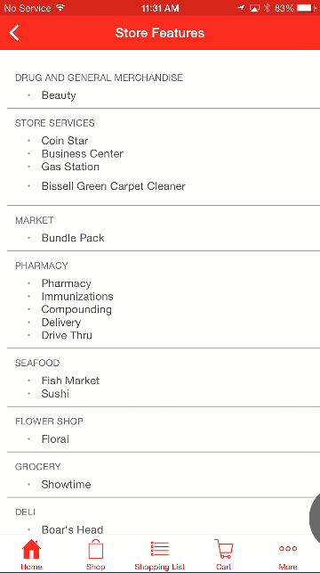

On clicking “<” icon , again the Store Details page is getting displayed

On clicking the “ Get Directions “ link

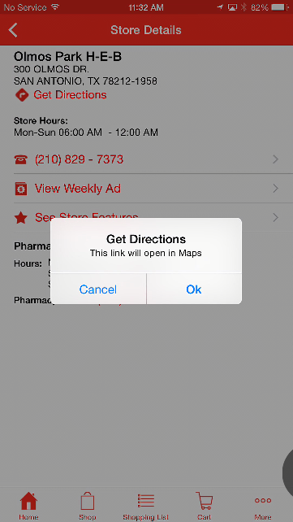

On clicking “ OK” it navigates to Map

List view on the Store location page by clicking the “ List “ tab in the Map view

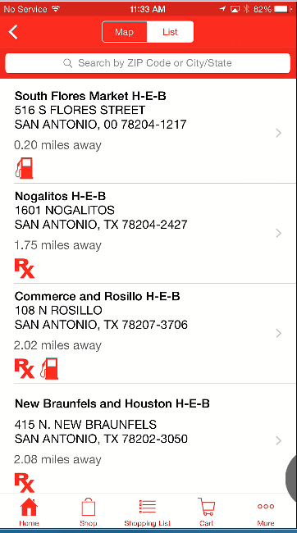

In case of Hot user the store details page will look like below

**Hot user Home page look:**

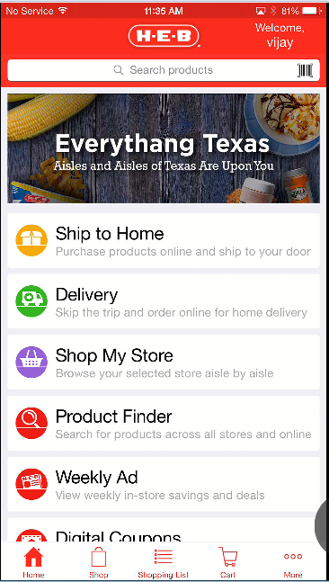

Hot user Store Locator page look

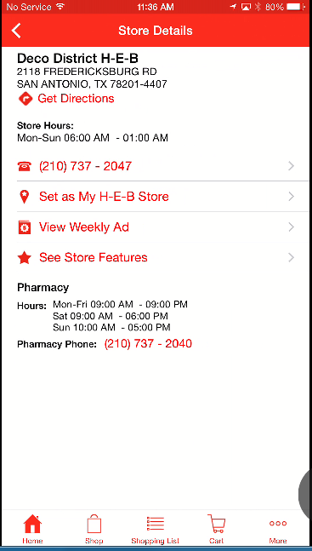

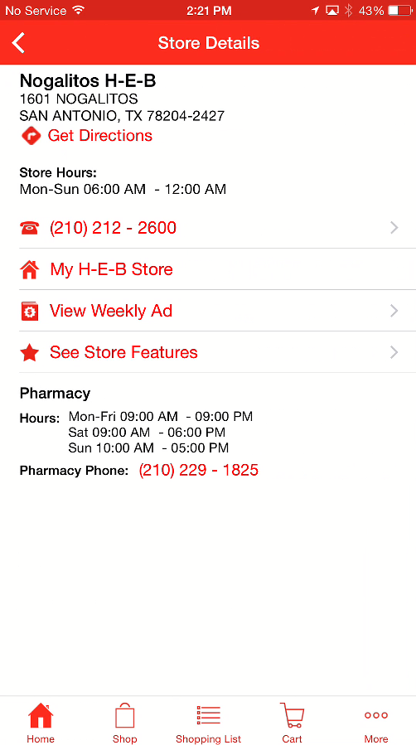

Hot user Store locator Map view page

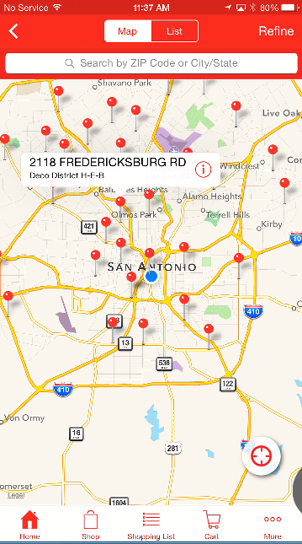

You can see the “ Refine “ button will appear only for Hot user

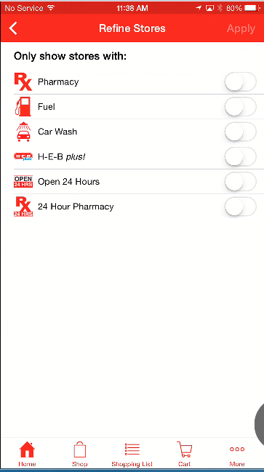

On clicking on the option , we can see “ Apply” will be enabled

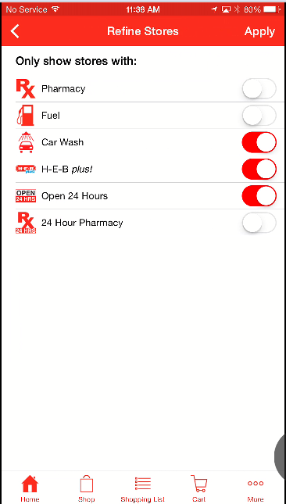

On clicking on “ Apply “ a refined search result on store location will be displayed for both the Map and List view

**Weekly Ads screen :**

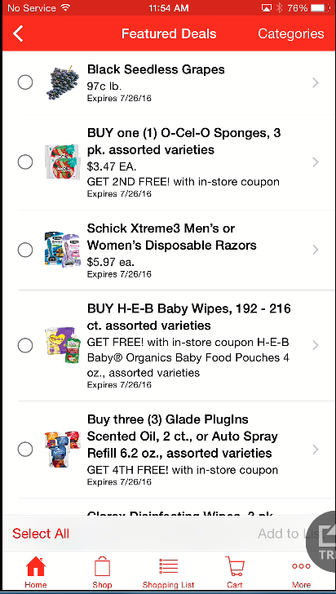

**Categories List**

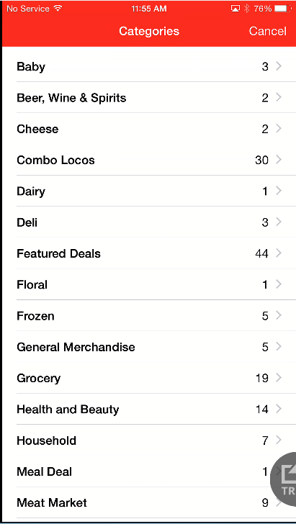

**Choosing : “Cheese”**

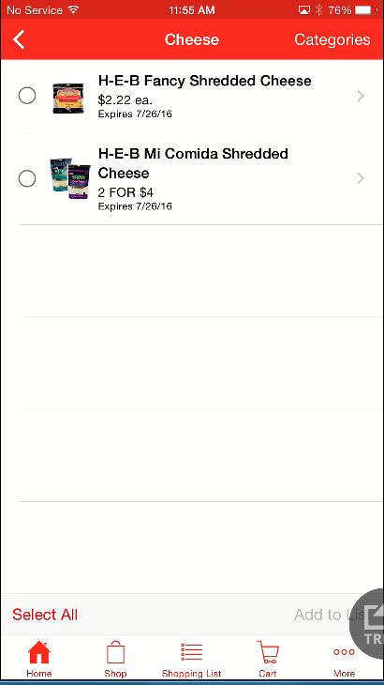

**Selecting an specific deal from the list**

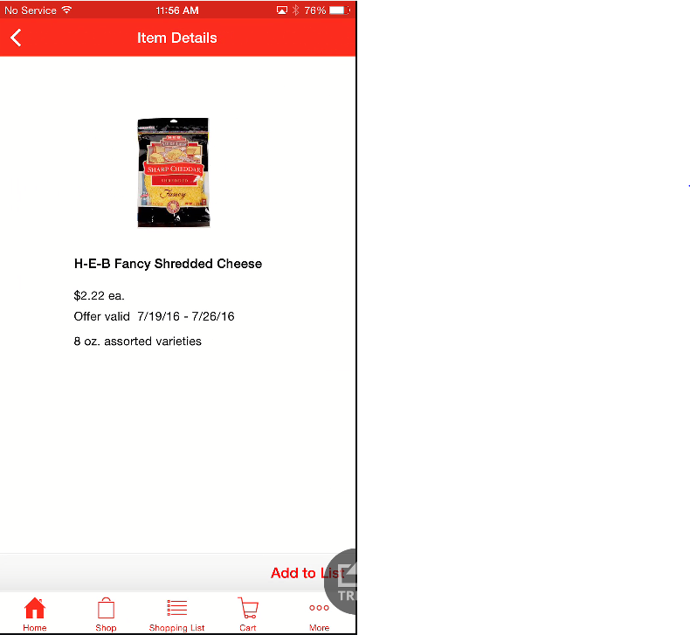

**Clicking on Add to List**

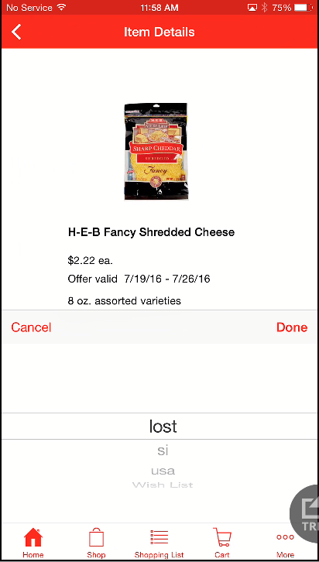

**Choosing the scroll list option as “Wish List “**

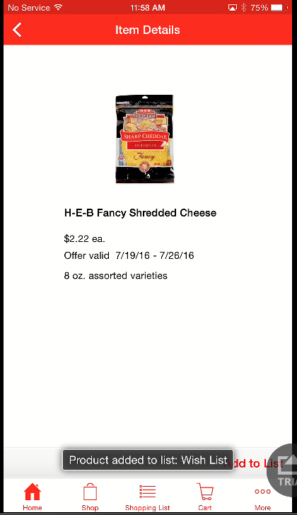

**Navigating to “Shopping List “ to cross check the added deal**

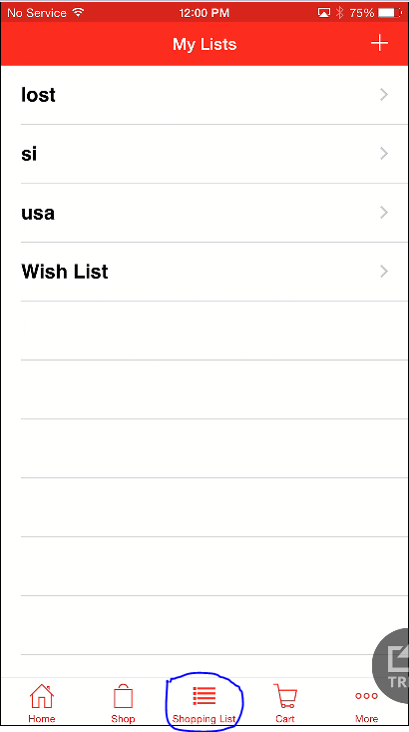

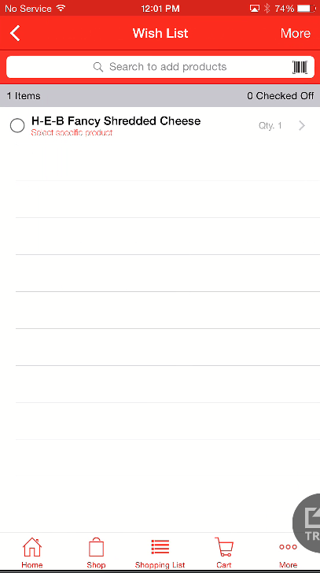

**The deal is added in the Shopping list**

**Again on clicking the deal in the shopping list the below screen is displayed**

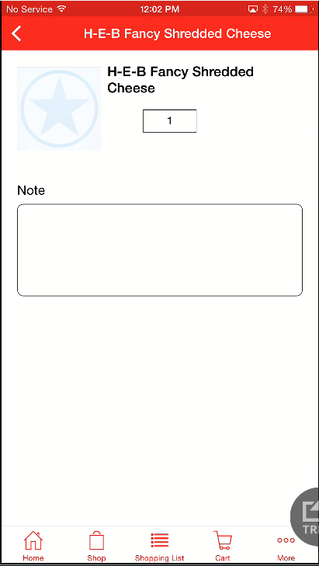

**Shopping List :**

**For Hot user :**

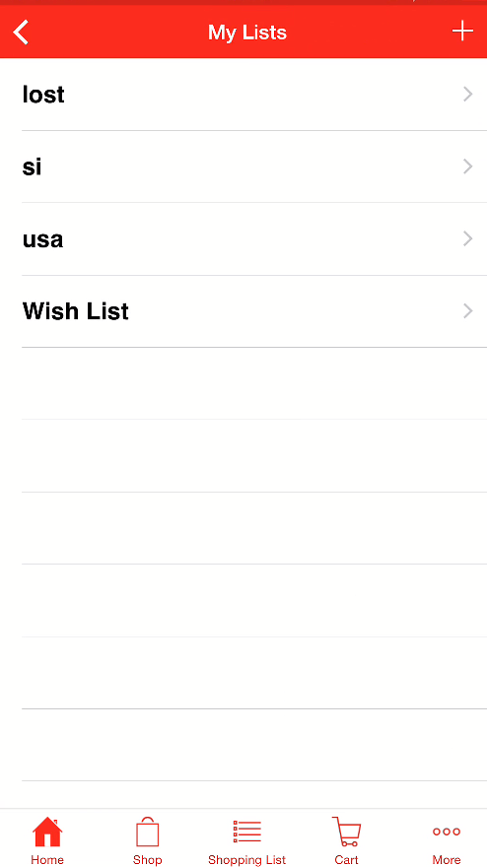

**Adding List**

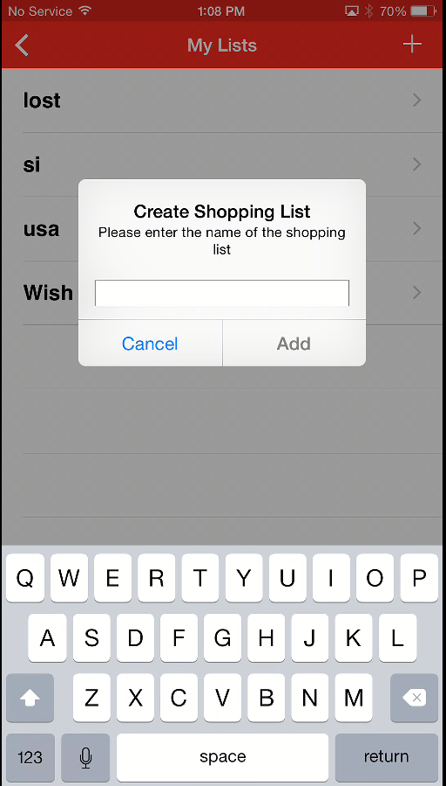

**Created “to buy “ list**

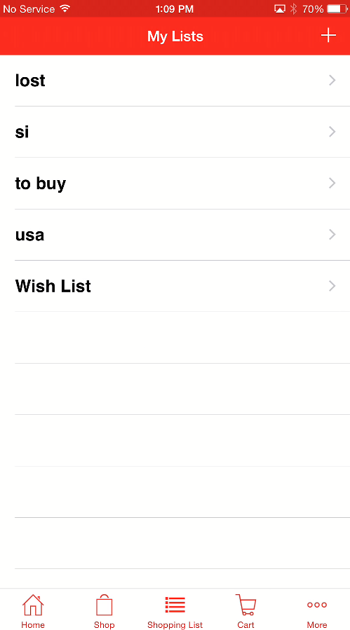

**Selecting a specific list . say “ to buy”** 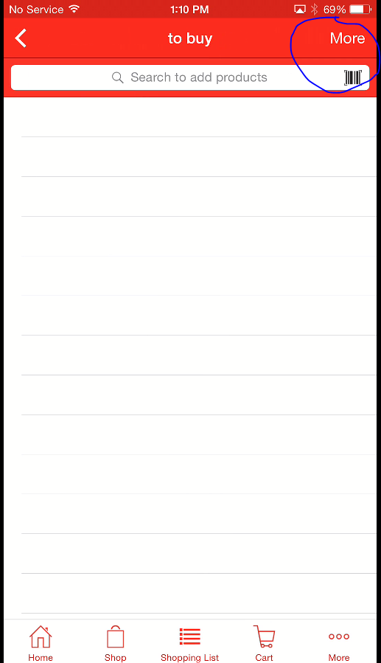

**We can see More icon .**

**Click on the More icon in the shopping list**

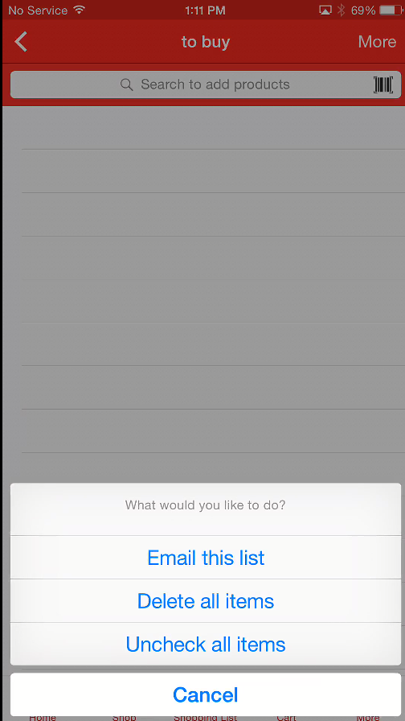

**Navigate back to the Shopping list by click “Shopping List “ icon.**

**To delete an List , swipe the list from right to left side** 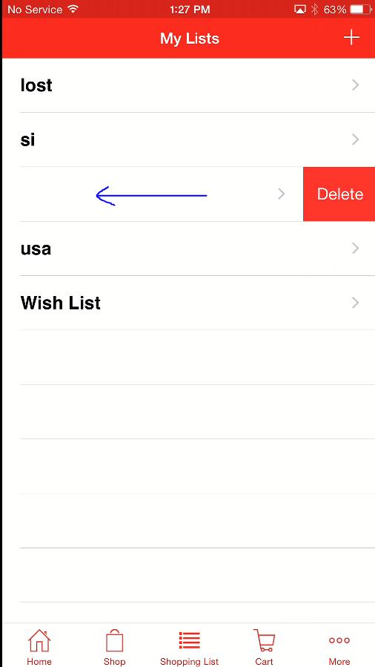

**And click on the “Delete” button . The new list will be deleted .**

**To validate :**

1. **Wish List is the default list for Hot User which cant be deleted .**

**Scan Receipts**

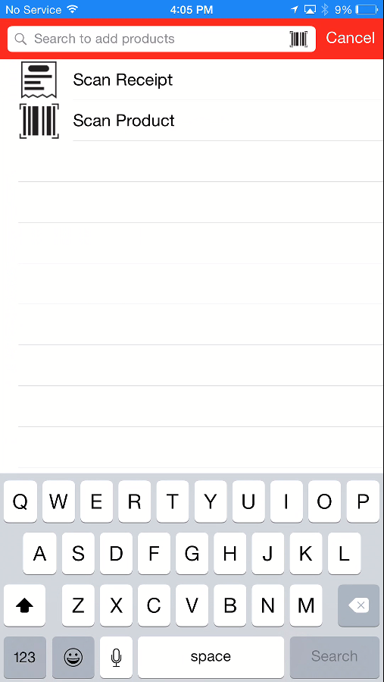

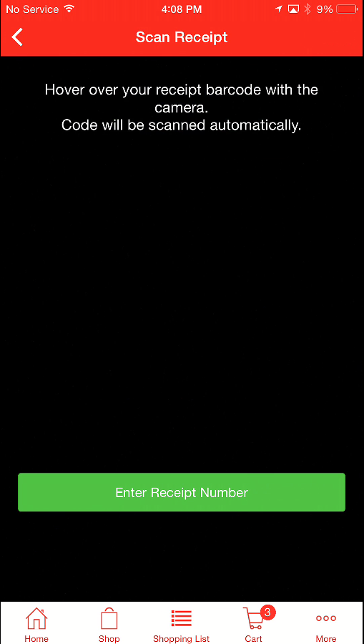

**Entering the receipt number**

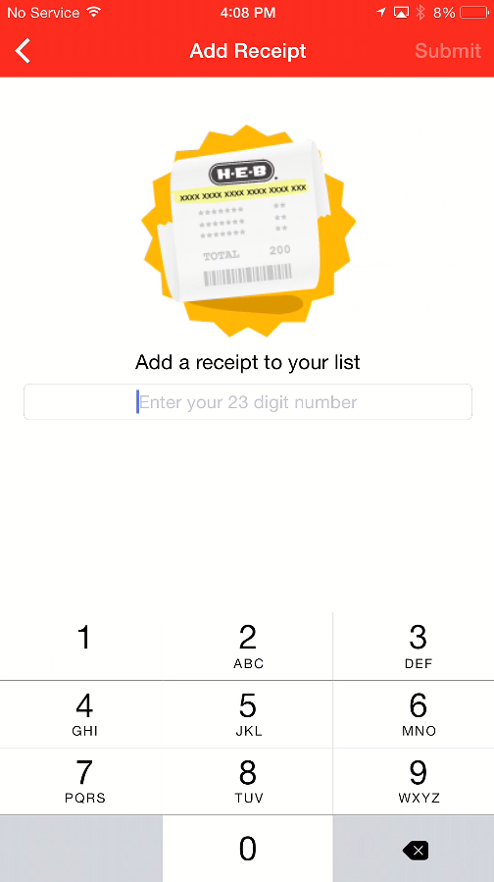

**Recipes :**

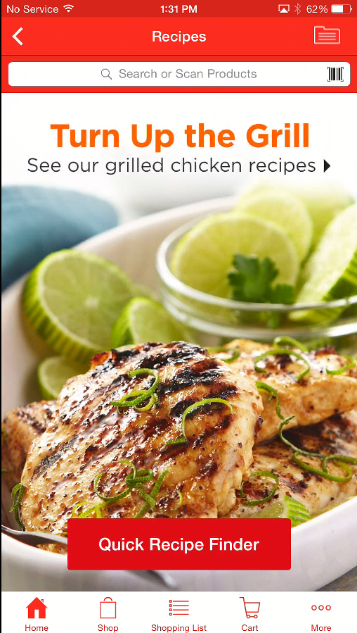

**Recipe landing page**

**On clicking on Quick Recipe Finder** 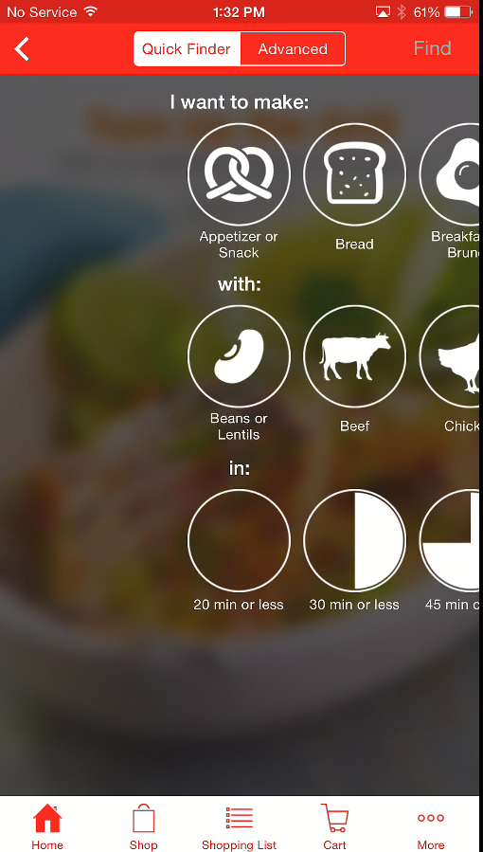

**On clicking on “Advanced”**

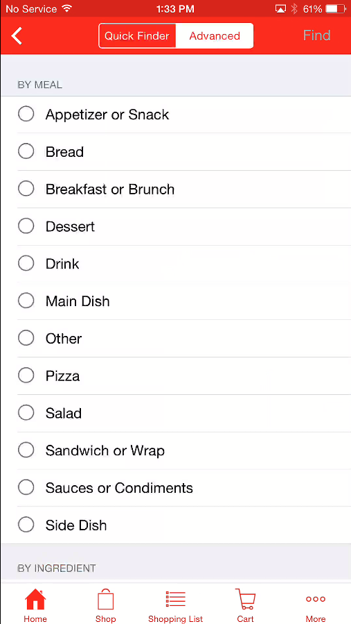

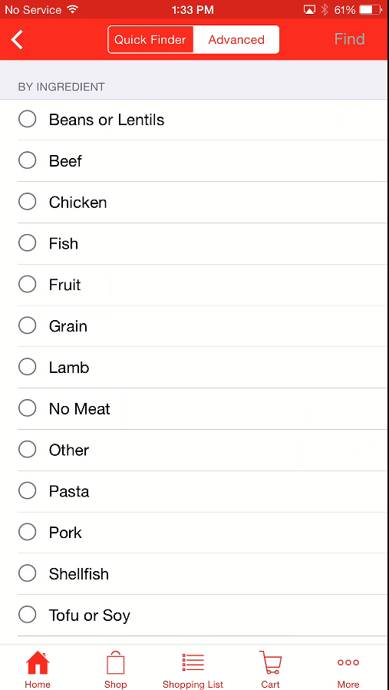

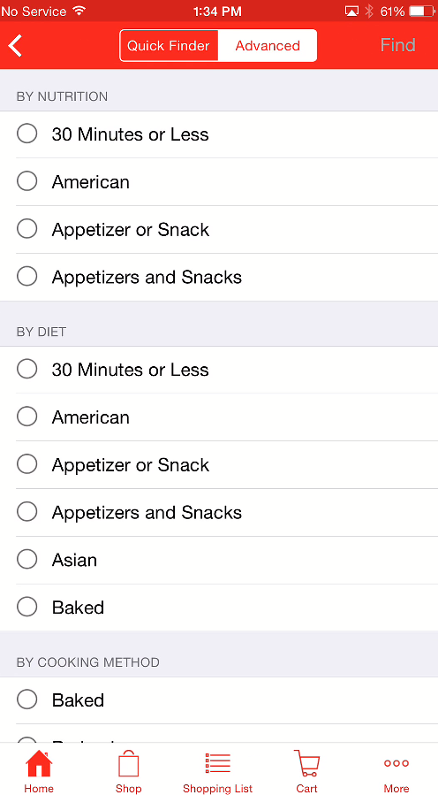

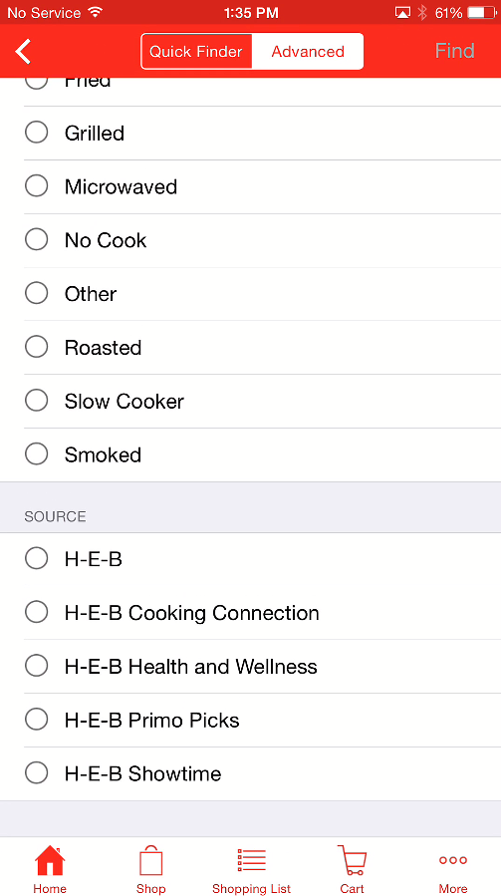

**No results Toaster Message**

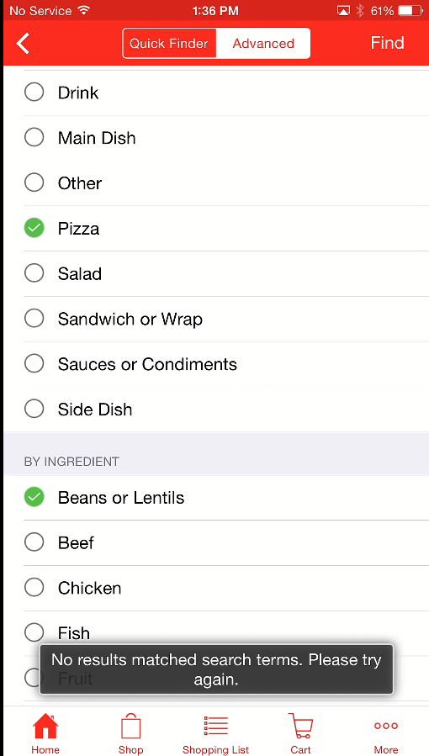

**On Choosing the correct combination[Pizza with chicken ] we will get the below screen** 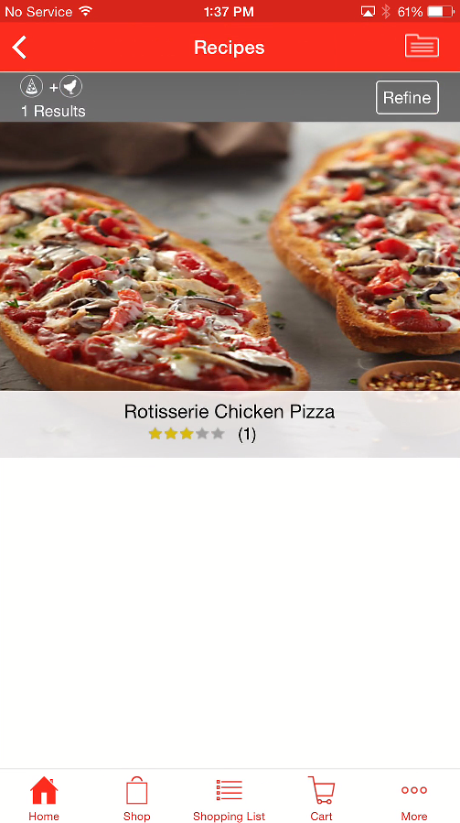

**On clicking on refine from wither Advanced/Quick Find , it should go to the Advance search from where it was initially navigated**

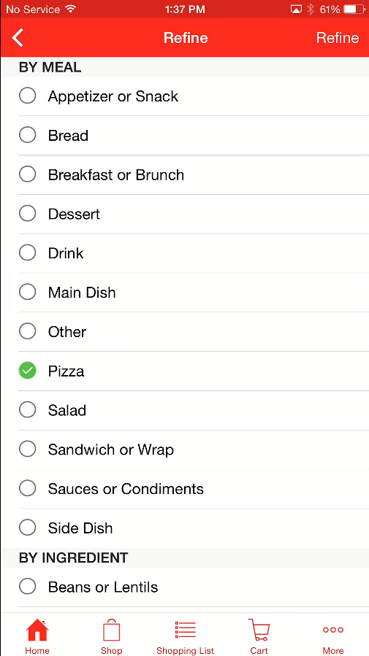

**If we try to navigate to the Quick finder page by clicking the “<” back icon twice**

1. **First “<” takes from refine page to previous search result page**
2. **Second “ <” takes you from search result page to Quick Finder/Advanced** 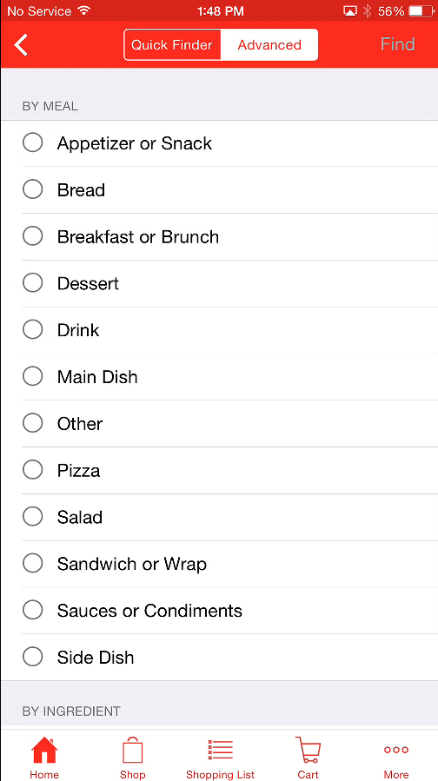

**All the previous selected options will be reset**

**On choosing the Quick Finder button**

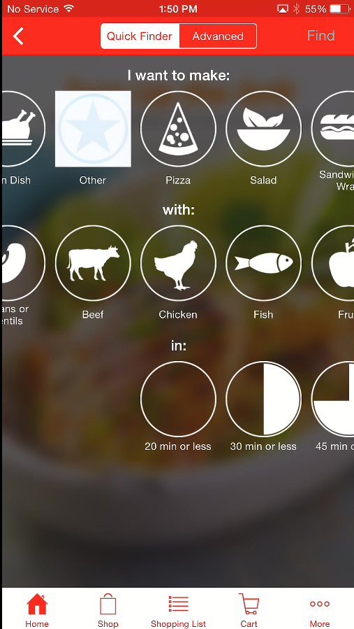

**We can see the selected options aligned as previous selected options .**

**But it will not be highlighted**

**Error Search Message when we tried to click on “Find” when no combination is selected in**

**Quick Finder view** 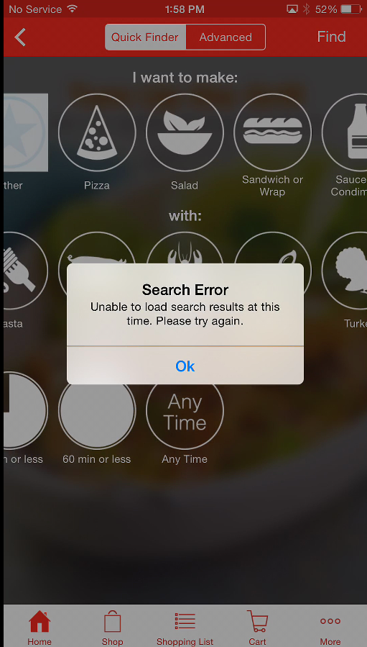

**Note: This is possible when we navigate from result page back to re-search or change the combination**

**This is applicable for both Quick Finder and Advanced**

**Searching Recipes through search text**

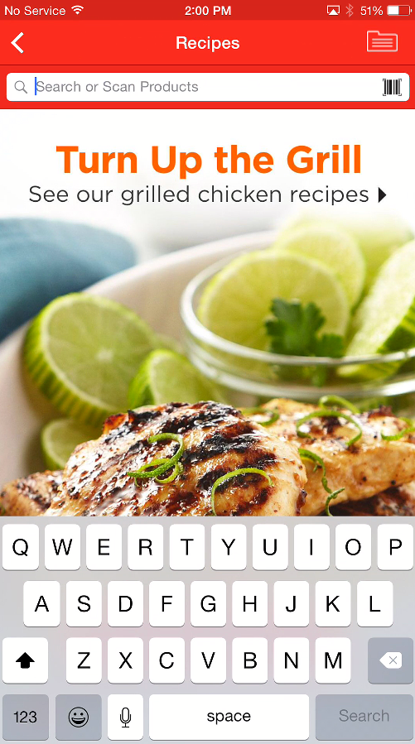

**My RecipeBox which is applicable only for Hot** 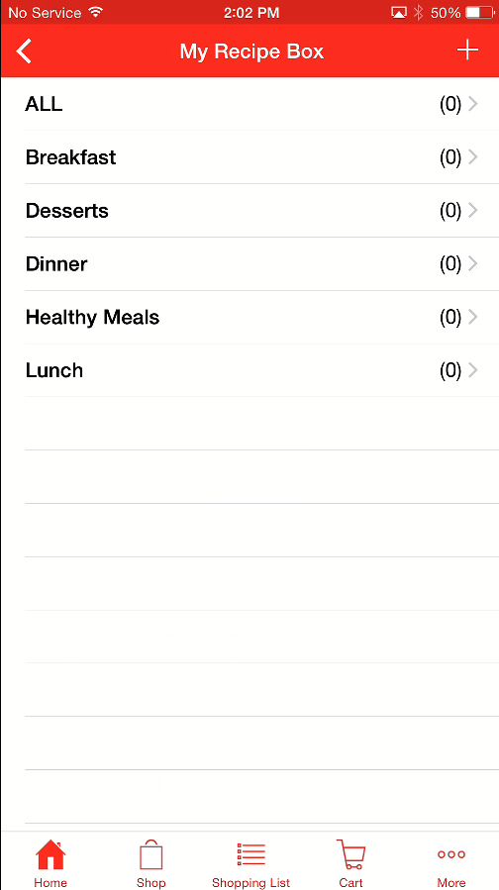

**Adding in recipe Box**

**Create Folder**

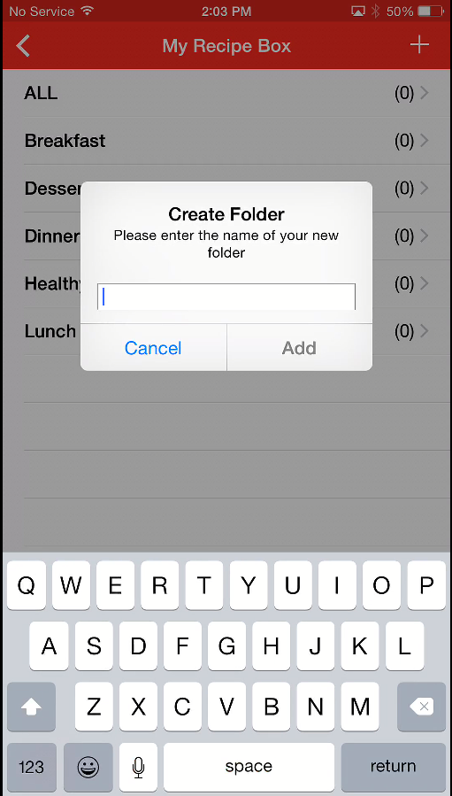

**Created a folder as “ my organics “**

**Chosing/clicking the folder** 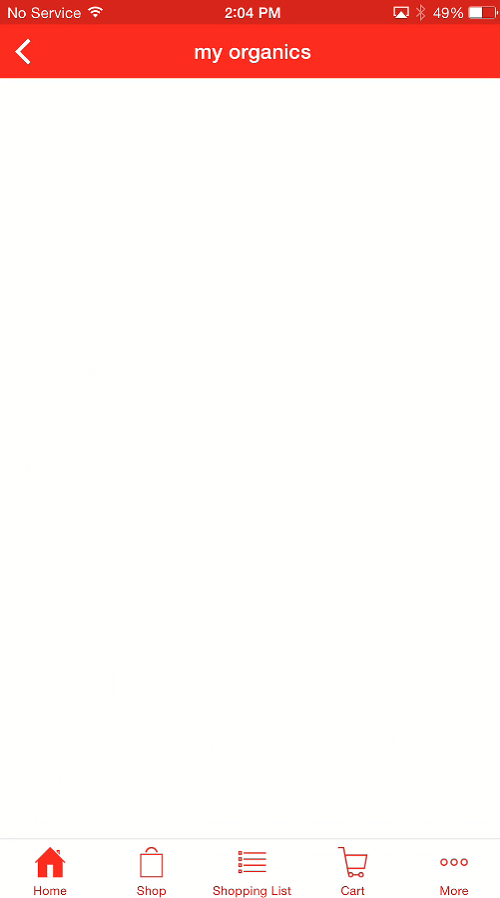

**Deleting the Recipe Box folder is similar to deleting the shopping list entries**

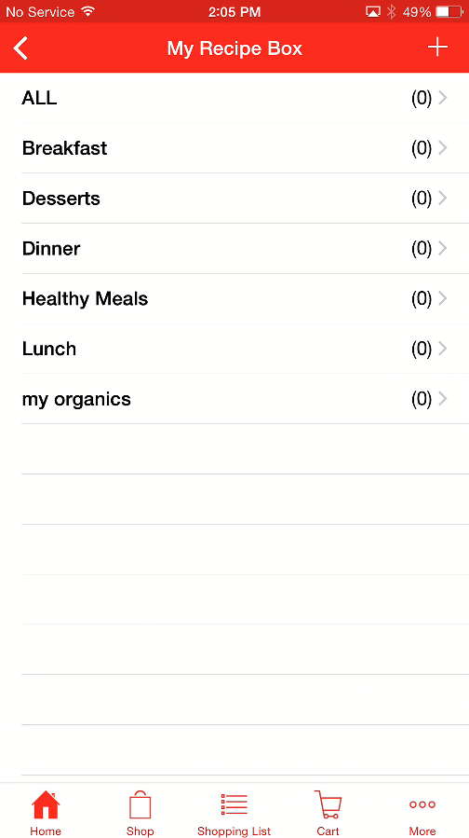

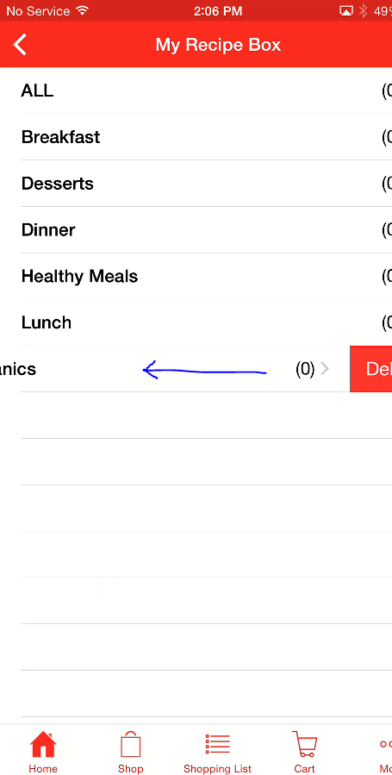

**Click on the “delete” icon . The created folder will be deleted**

**Note :**

**We will be having a folder called “ ALL” which is the default folder which cant be deleted.**

**Choosing an recipe :**

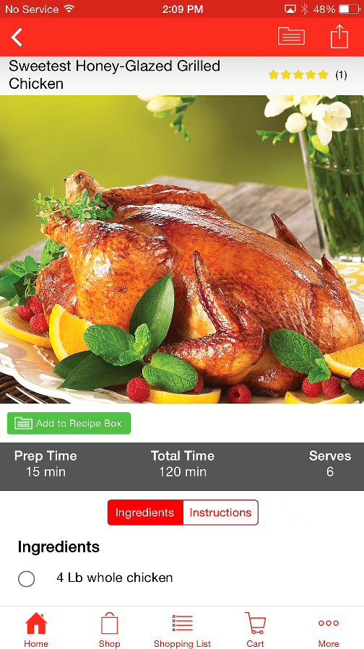

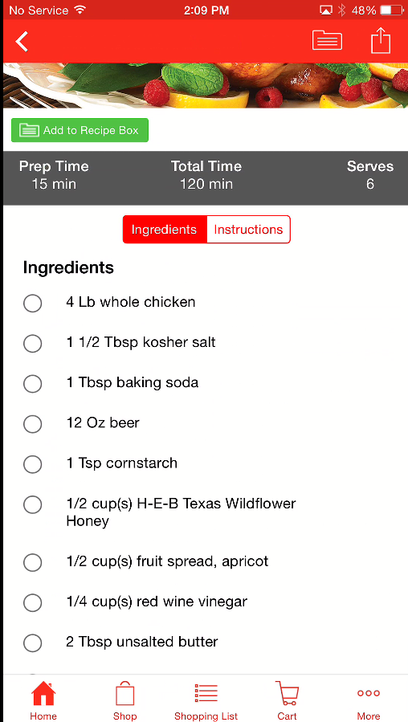

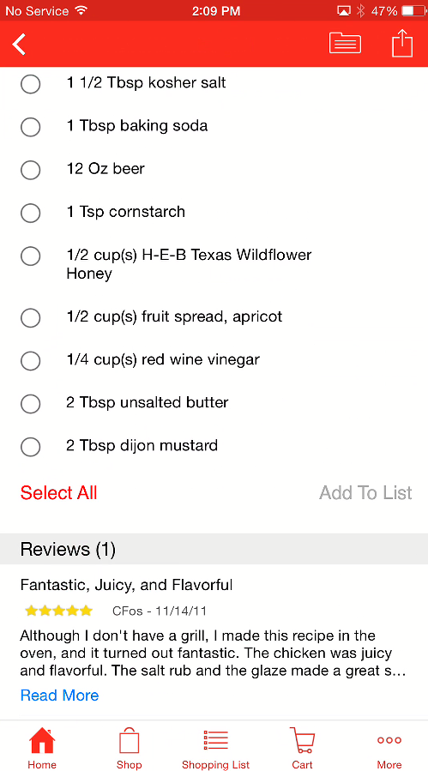

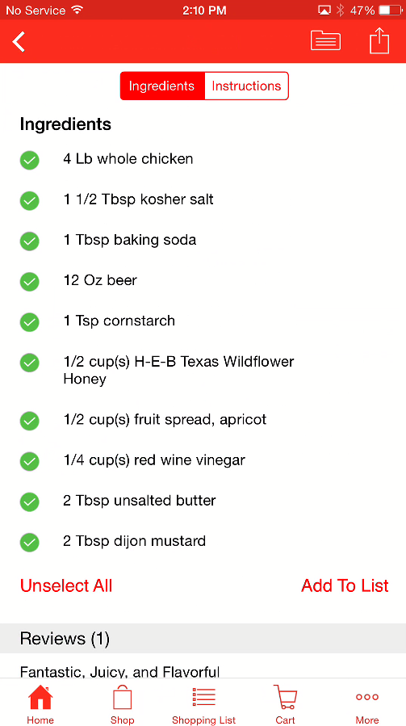

**Adding to shopping List**

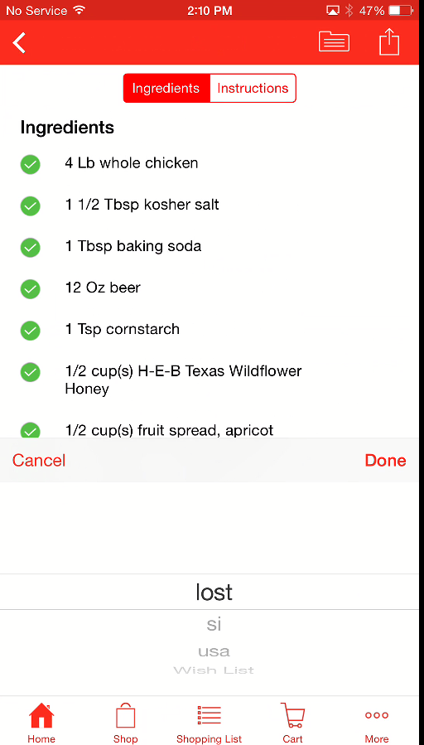

**Adding to Recipe Box** 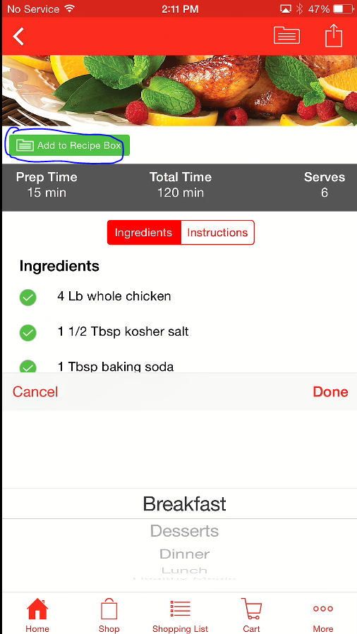

**Adding to Recipe Box. Toaster message is getting displayed** 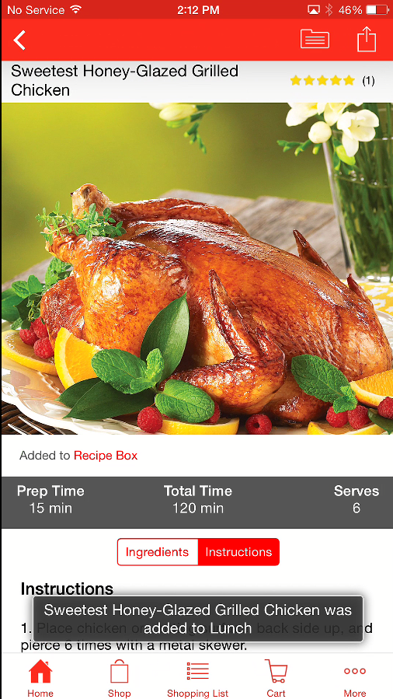

**Instructions section**

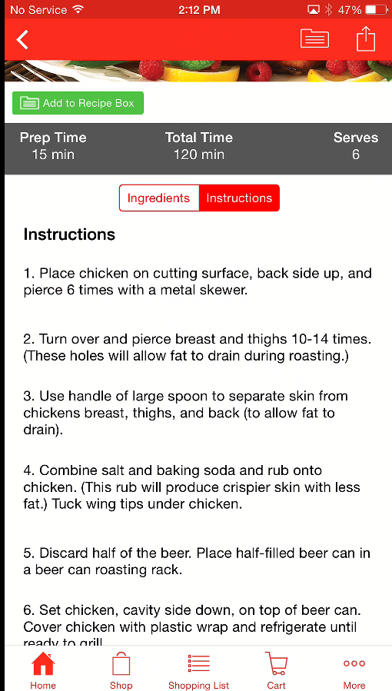

**Sharing icon :**

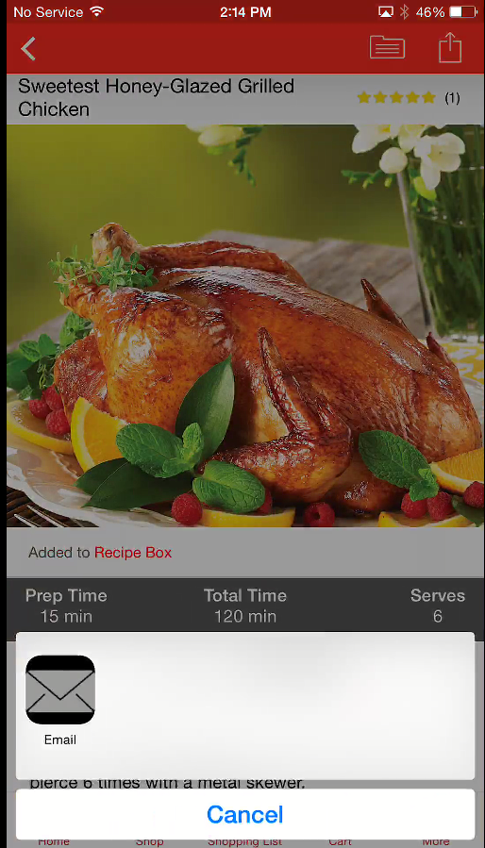

**As a Cold user :**

**When user clicks on recipe Box will get a screen as below** 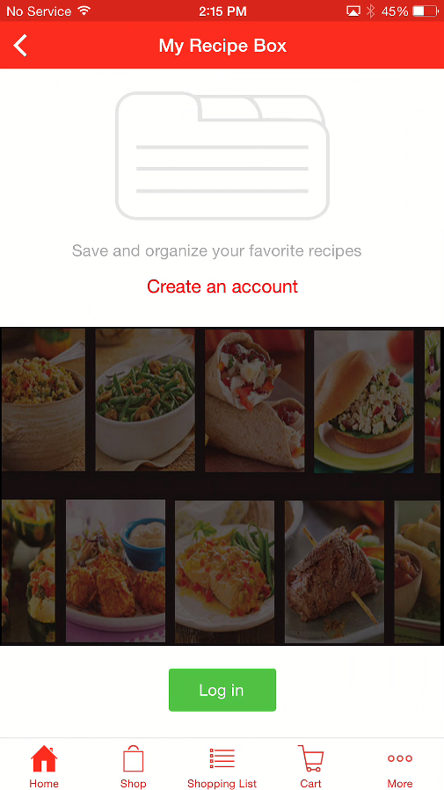

On clicking the “Create Account “ . The user should be navigated to the Registeration page

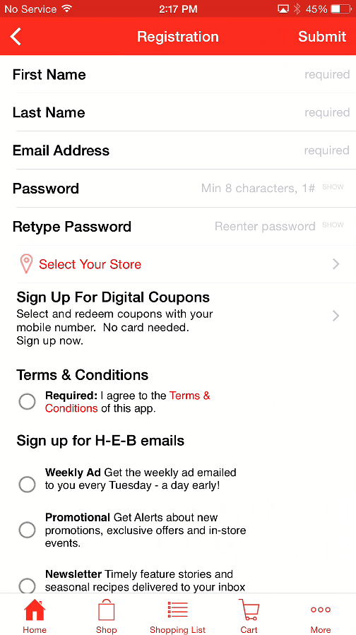

Error message in registeration page 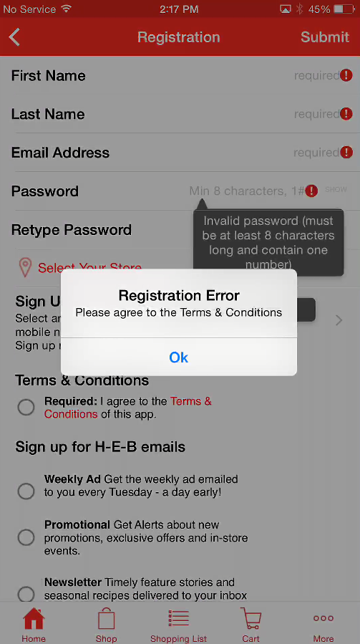

On clicking Login in the Recipe page the user should be navigated to the Login page

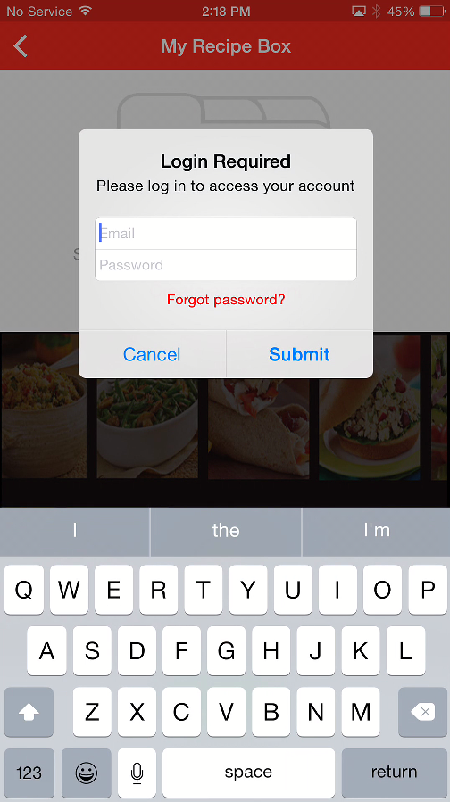

**Mobile Wallet Screens** 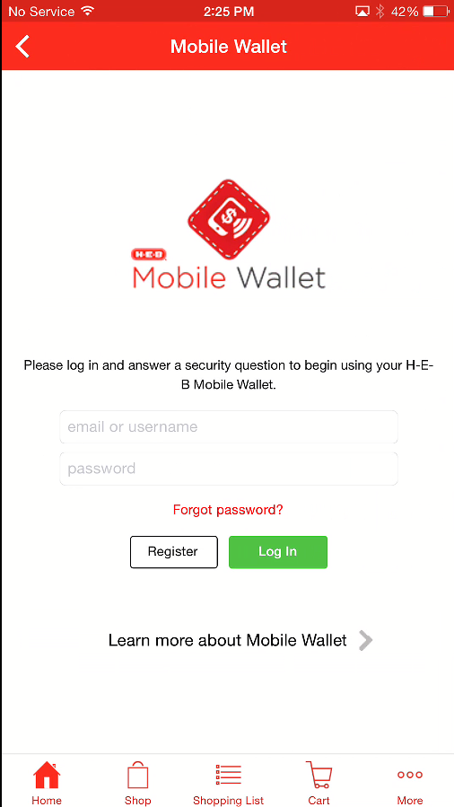

After registeration and second time navigation to the Mobile Wallet section , we will get the below screen

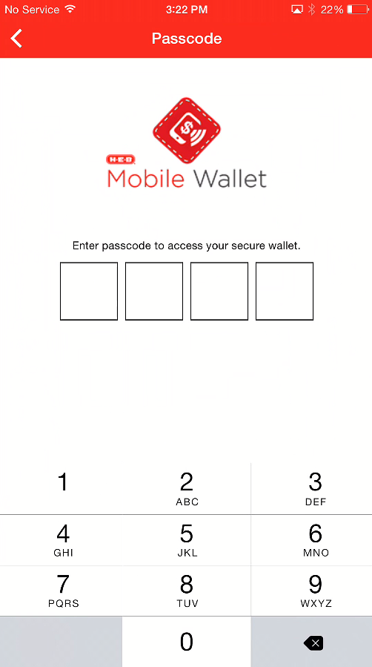

After entering the Pin details 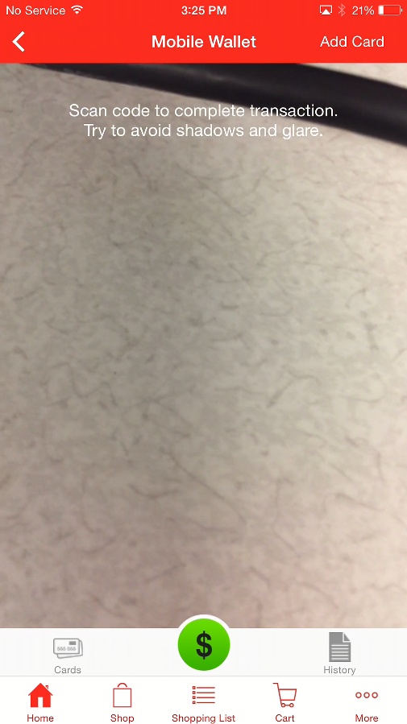

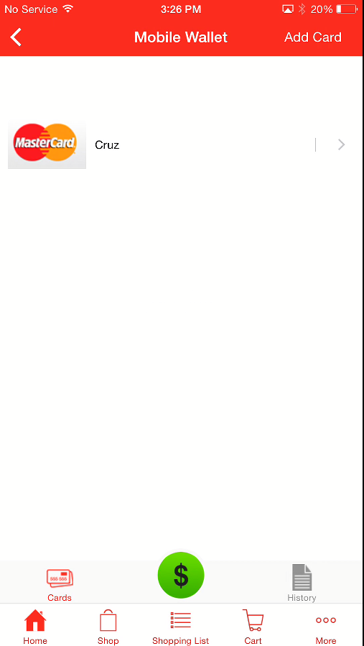

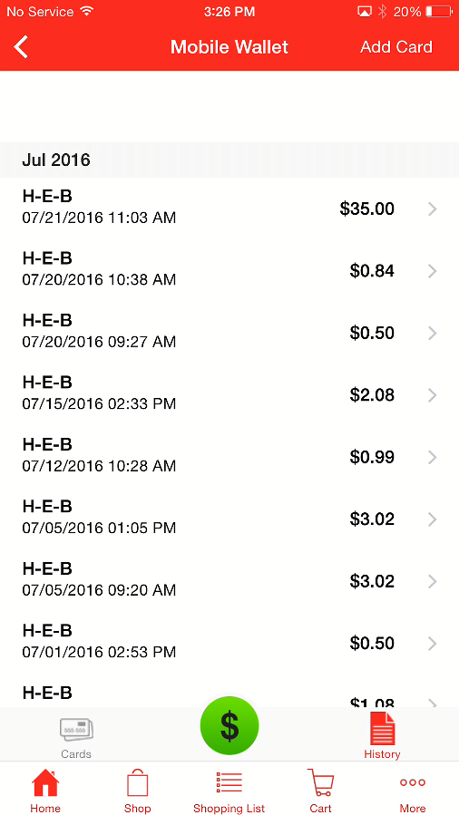

Add Card

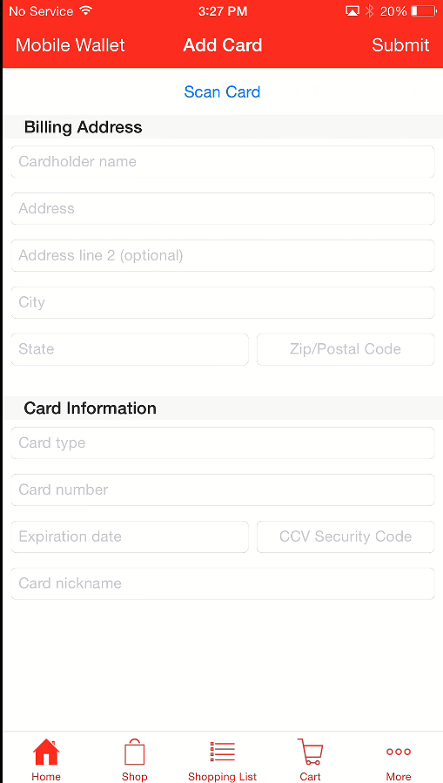

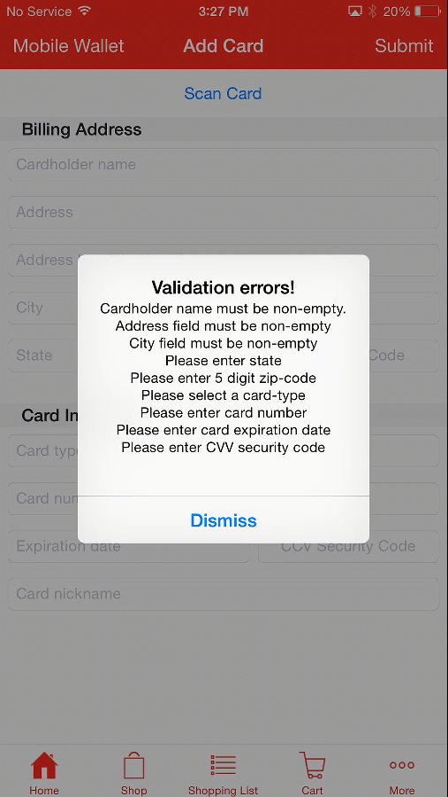

Under More option in Iphone

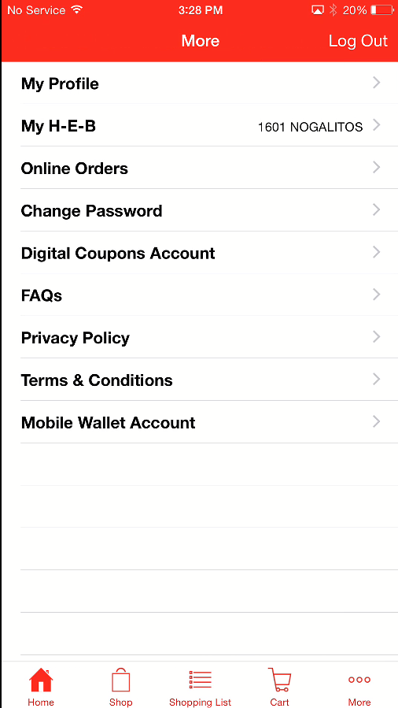

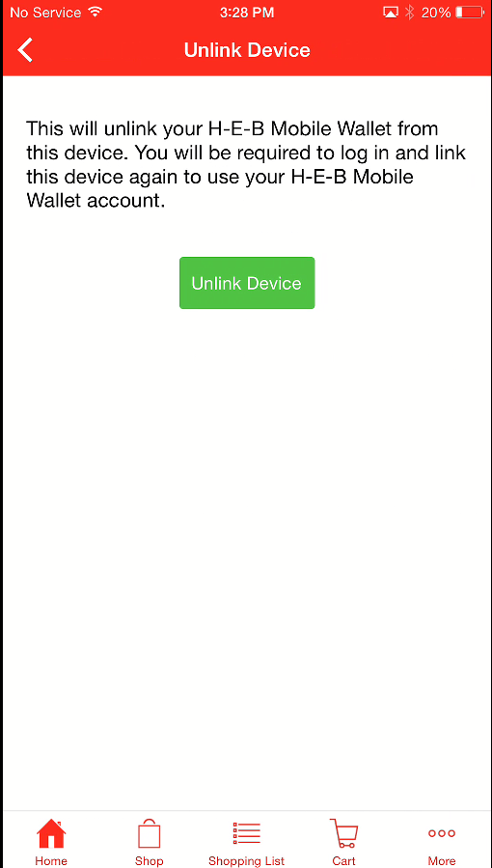

Just do the page validation on Cart section

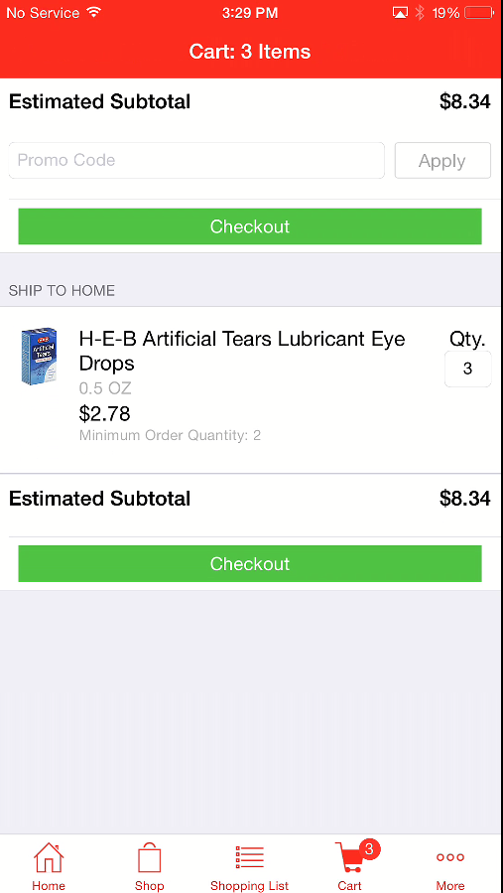

Digital coupons

For First time visit in Digital coupons

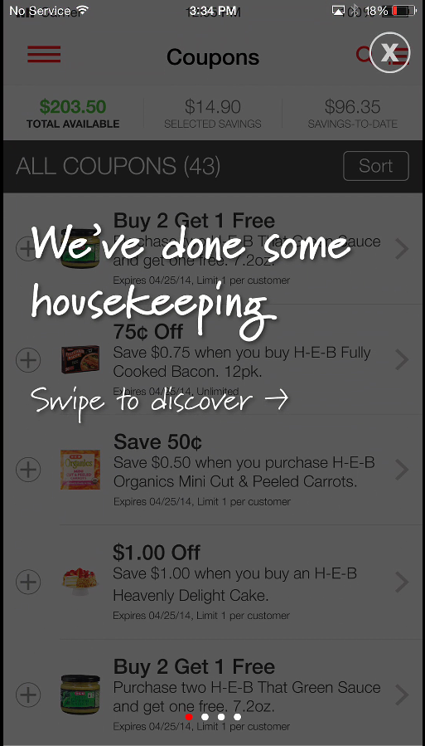

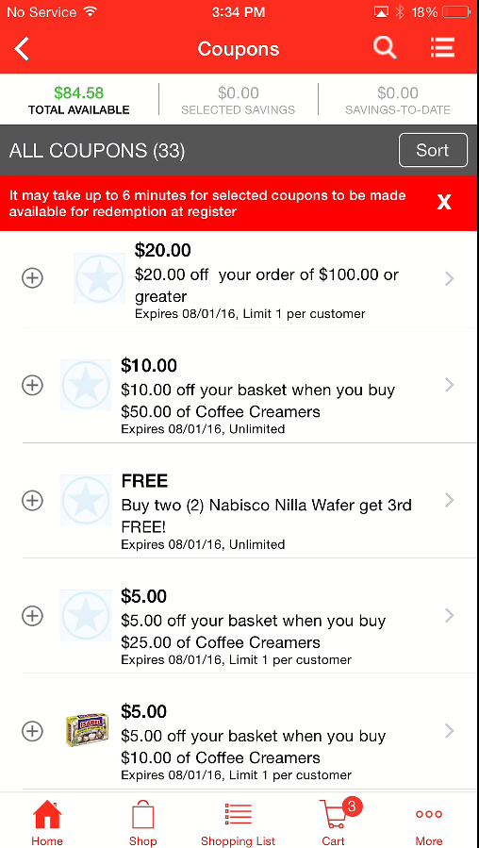

Coupons categories

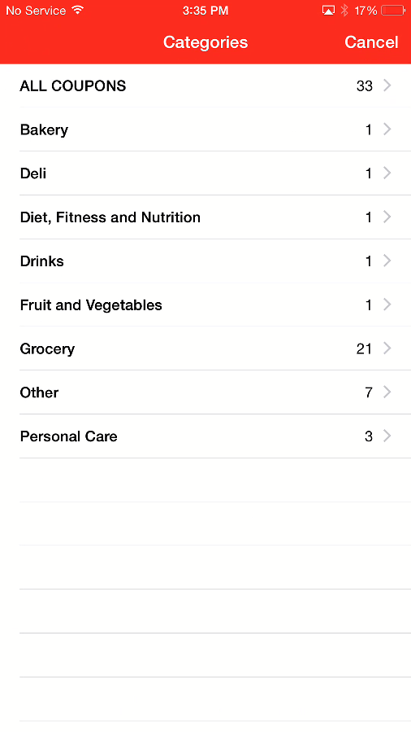

Filter in Coupons , but clicking “Sort” 